**CS523 - Big Data Technology Project**

**TeamMembers**

Suresh Prajapati(109524)

Sovichea Cheth(985421)

Sunena Gwachha(109578)

**Part 1: Spark Streaming**

**#Spark installation**Step 1: <http://download.nextag.com/apache/spark/spark-2.3.0/spark-2>.3.0-bin-hadoop2.7.tgz  
Step 2: tar -xvzf spark-2.3.0-bin-hadoop2.7.tgz  
Step 3: mv spark-2.3.0-bin-hadoop2.7 /usr/local/spark

**Part 2: HBase through Spark SQL**

Step 1: Import library files

Step 2: Convert bytes to string

Step 3: Create temporary table YouTube

Step 4: Run spark SQL query

**Part 3: Data Visualization**

**#Zeppelin installation**Step 1: Download Zeppelin http://www.apache.org/dyn/closer.cgi/zeppelin/zeppelin-0.7.3/zeppelin-0.7.3-bin-all.tgz

Step 2: Extract and put in any directory

Step 3: Set up SPARK_HOME and JAVA_HOME in .bashrc

Step 4: Update Zeppelin config files

Zeppelin-env.sh zeppelin-site.xml

Step 5: Start Zeppelin

Sudo bin/zeppelin-daemon.sh start

Step 6: Open localhost:8080 will display Zeppelin

Step 7: Import HBase data, run the query and observe the result

**Screenshot of Query1 and Query2**

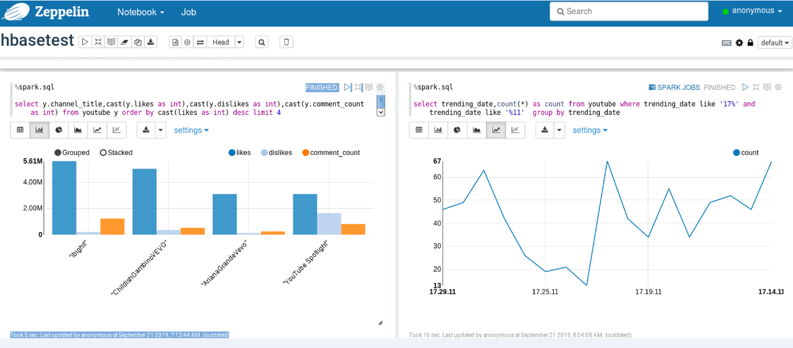

**Query 1**

%spark.sql

select y.channel_title,cast(y.likes as int),cast(y.dislikes as int),cast(y.comment_count as int)

from youtube y

order by cast(likes as int) desc

limit 4

**Query 2**

%spark.sql

select trending_date,count(*) as count

from youtube

where trending_date like '17%' and trending_date like '%11'

by trending_datePart

**4: Kafka**

**#Kafka installation**Step 1: http://mirrors.sorengard.com/apache/kafka/1.0.1/kafka_2.12-1.0.1. tgz  
Step 2: tar -xvf kafka_2.12-1.0.1.tgz  
Step 3: edit .bash_profile to add 2 line below  
 export KAFKA_HOME=<location of kafka>  
 export PATH=$PATH:$KAFKA_HOME/bin  
Step 4: start zookeeper   
 ./bin/zookeeper-server-start.sh config/zookeeper.properties  
Step 5: start kafka  
 ./bin/kafka-server-start.sh config/server.properties  
Step 6: create topic  
 ./bin/kafka-topics.sh --zookeeper localhost:2181 --create --topic --replication- factor 1 -partitions 1 -topic topicname  
Step 7: list topics  
 ./bin/kafka-topics.sh --list --zookeeper --localhost:2181

Step 8: Connect to Zookeeper instance

zookeeper-shell.sh localhost:2181 ls /brokers/topics

Step 9: Remove the topic folder from ZooKeeper

rmr /brokers/topics/yourtopic

Step 10: Start Producer

bin/kafka-console-producer.sh --broker-list localhost:9092 --topic YTVideo

Step 11: Start Consumer

kafka-console-consumer.sh --zookeeper localhost:2181 -topic YTVideo --from-beginning

Export the project to runnableJar file through eclipse. And run following command on terminal.

hadoop jar Desktop/kafkademo.jar YTVideo Desktop/USvideos.csv;

